**TASK 1**

**Q.1** If we use adduser command to create a new user then a folder is created in /home directory but no directory is created when creating user using useradd command. Why?

**Solution:** The useradd command only creates the user since it is a low level utility for adding user. We will have to create the directory for the user explicitly in /home directory. While the command adduser will add users to the system according to command line options and configuration information in /etc/adduser.conf. It will automatically create a directory for user in the /home directory. Also when we check the /etc/passwd file then the last field, that is, the user shell for ‘**adduser**’ is **bash** (/bin/bash) and for ‘**useradd**’ it is **sh** (/bin/sh).

(User shell field contains the shell that will be spawned or the command that will be run when the user logs in.)

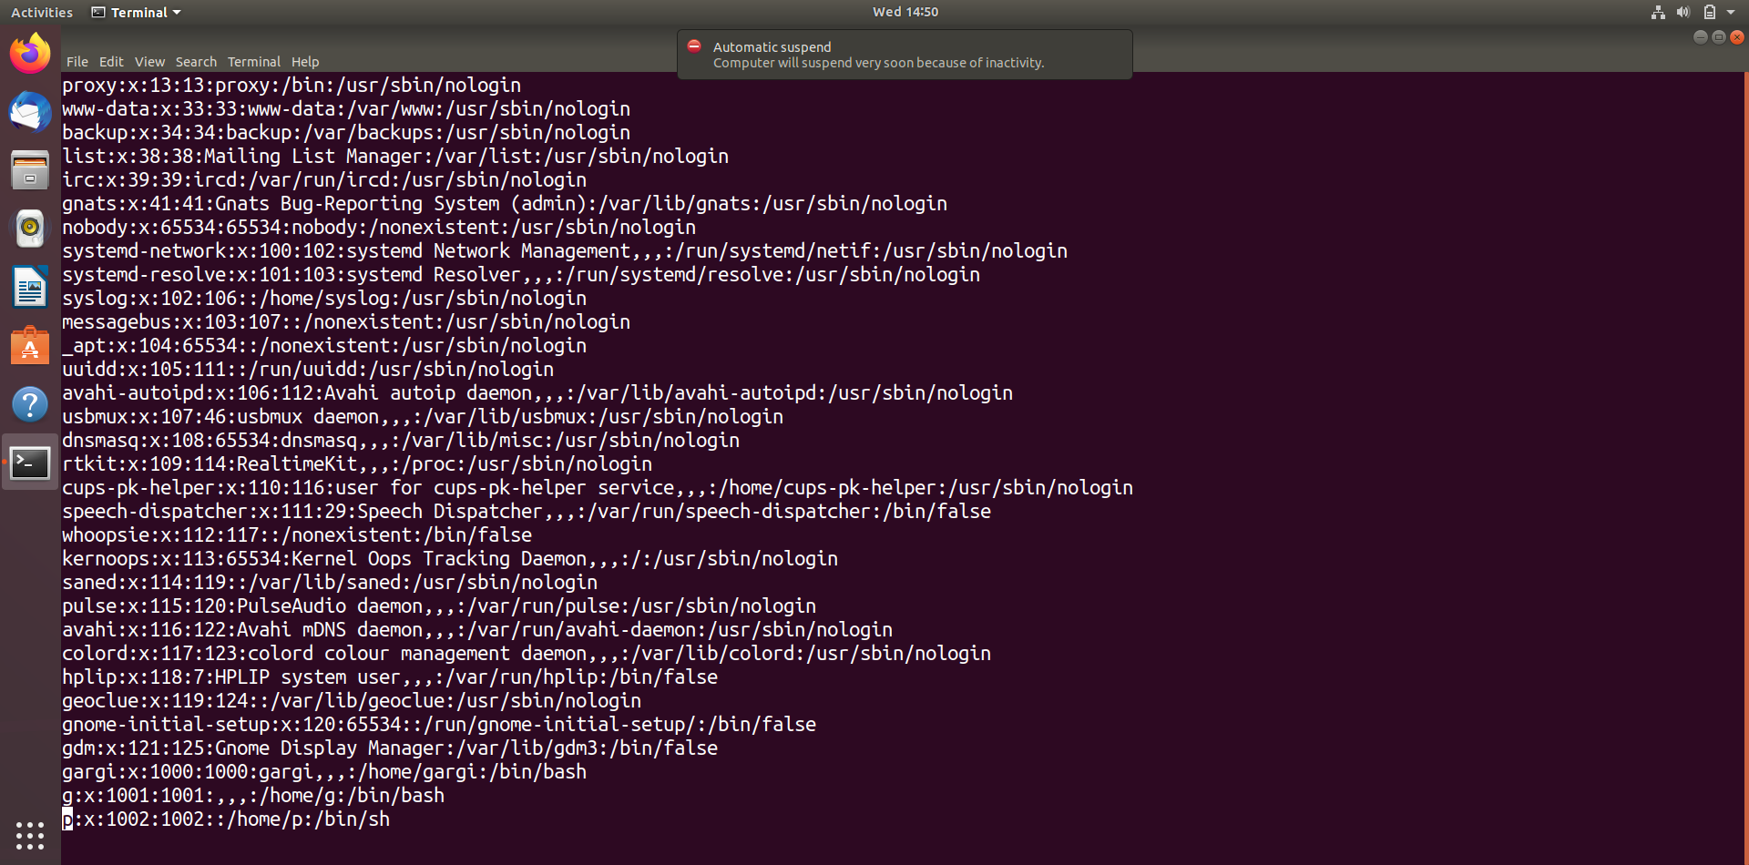

In the above screenshot from ubuntu, **g** is the user created using **adduser** and **p** is the user created using **useradd** command.